- Workstation:
- Evidence off all specifications:
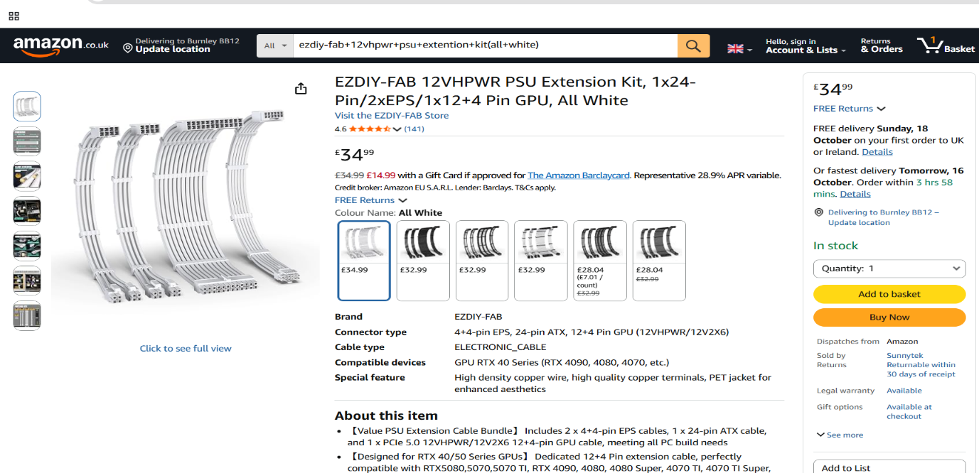

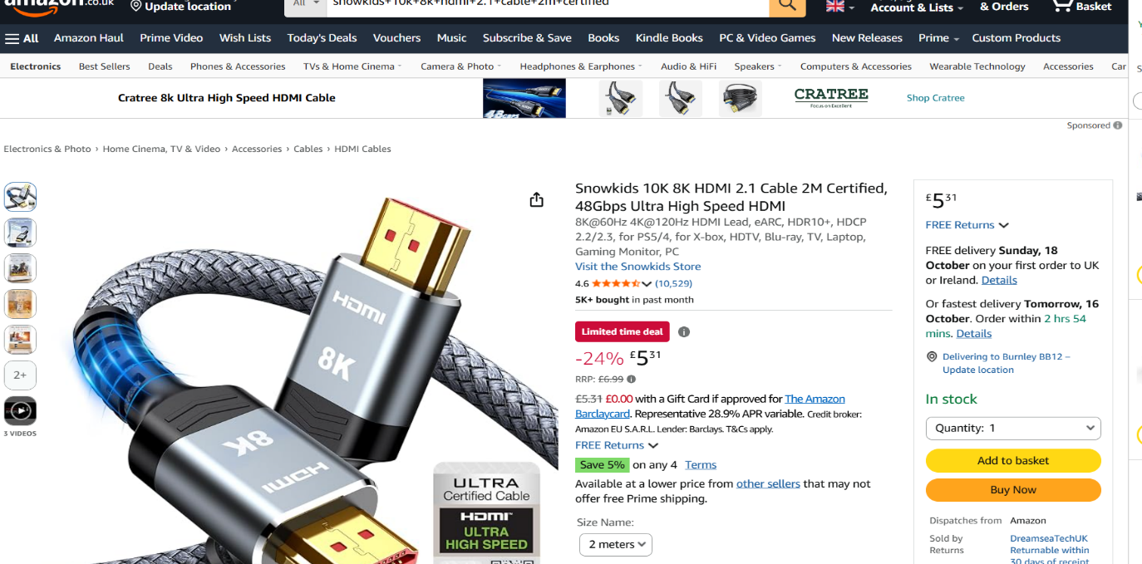

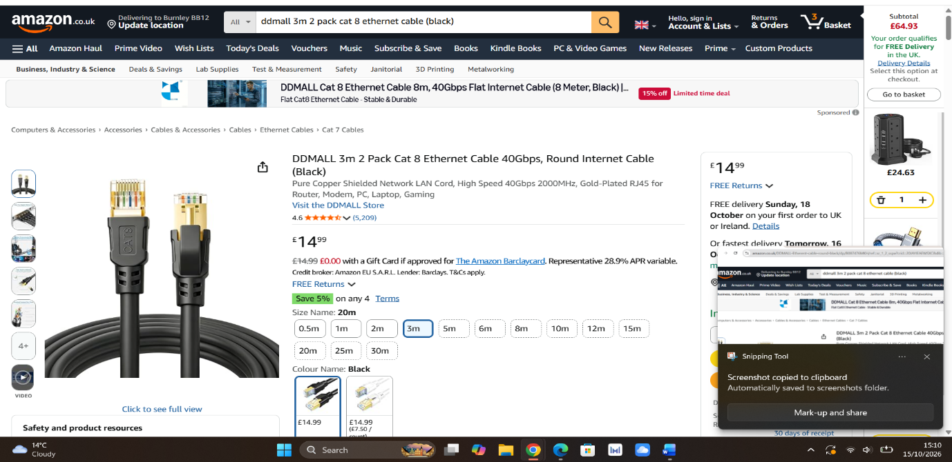
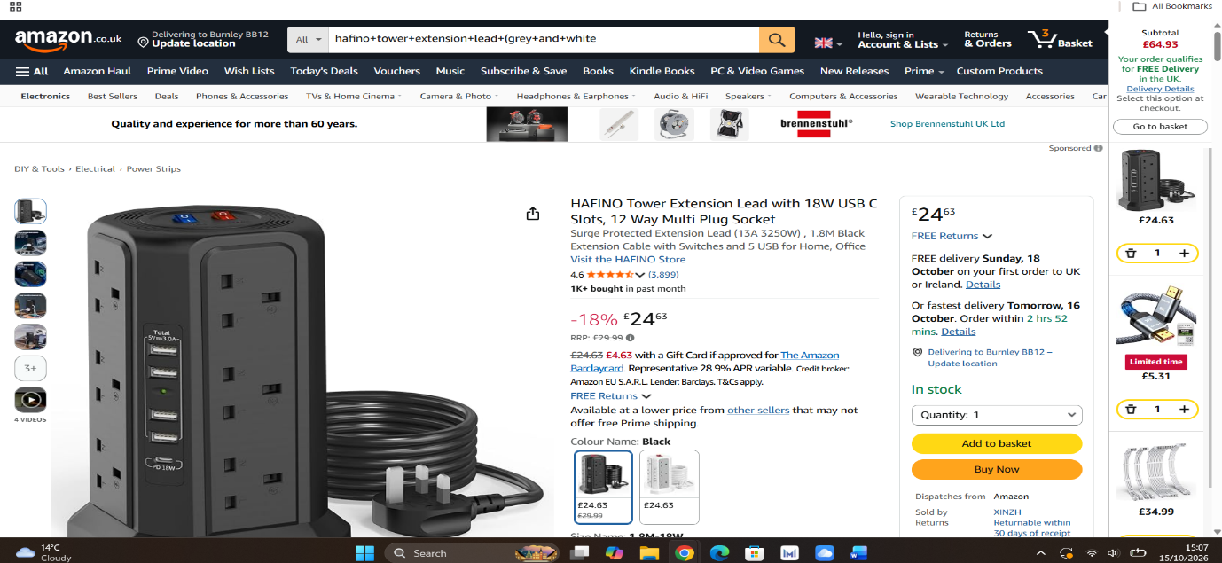

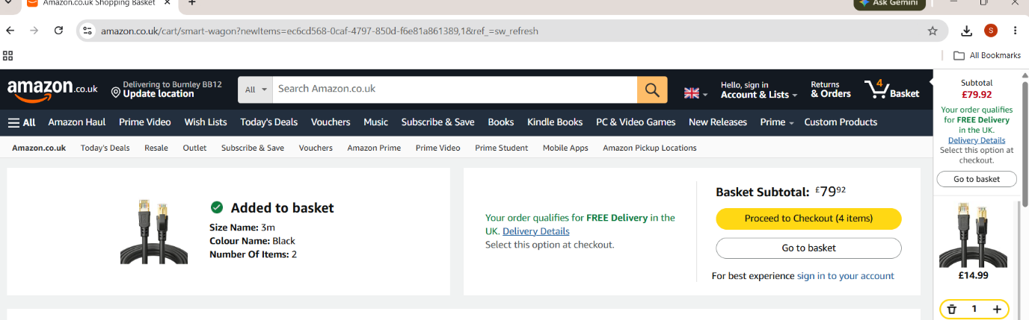
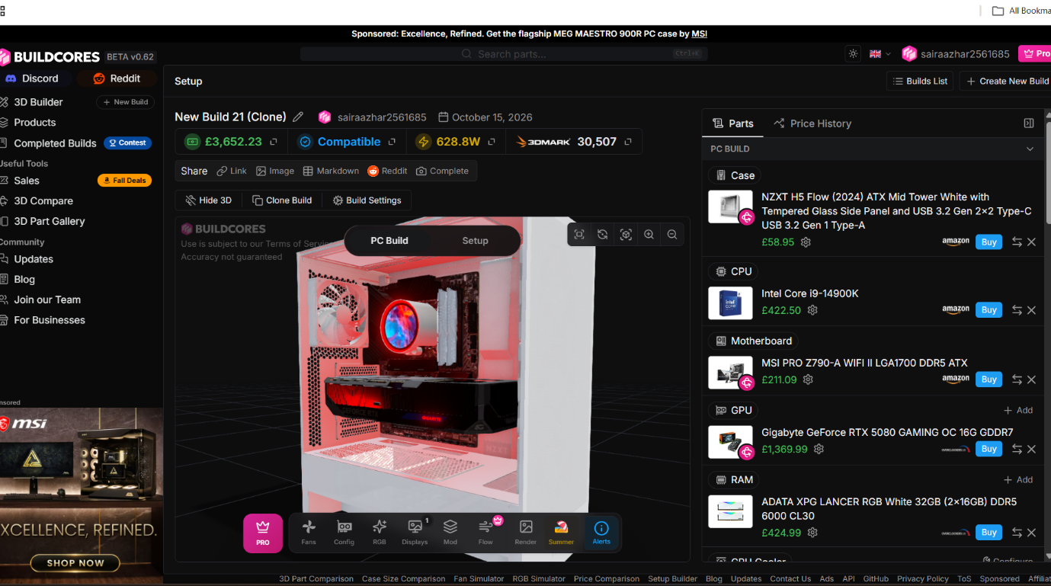

- Workstation justification:

- Case — NZXT H5 Flow (White):
This case contains big panels on the front and bottom sides, and this is a really good thing because air flows into the PC through them. 3D rendering computers work for long hours. The main parts produce a lot of heat, so these panels help these PCs cool down and work fast. One more thing, this case comes with an ATX size that provides more space to use heavy/large parts like the motherboard and graphics card and can also be upgraded in the future.

- Processor (CPU) — Intel Core i9-14900K:
As everyone knows, the CPU is the brain of the computer, and the good thing is the chosen CPU provides 24 processing cores that work really fast. 3D rendering workstations usually work on heavy and complicated projects that sometimes make these PCs slow down and freeze. Having 24 cores is the specialty of this CPU because it makes the computer fast and smooth, as a big project is considered divided into 24 smaller tasks.

- Motherboard — MSI PRO Z790-A WIFI II:
The motherboard is the main circuit board of the computer where all the parts of the PC connect, and it is responsible for supplying power to those parts. This motherboard is a good choice for 3D rendering work because it provides a good amount of power and supports fast DDR5 memory, which handles large 3D PC projects easily and efficiently. It also contains built-in Wi-Fi and ports that help share large files in seconds without long waits.

- Graphics Card (GPU) — Gigabyte GeForce RTX 5080 GAMING OC 16G:
The GPU is the most important part of a 3D rendering PC. This graphics card is a nice choice for a 3D rendering PC because it provides 16GB of VRAM that supports high performance and gives good and smooth textures. It also has RT cores that provide good lighting and 3D effects fast in minutes instead of taking long hours.
- Memory (RAM) — ADATA XPG LANCER RGB White 32GB (2x16GB) DDR5 6000 CL30:
This chosen memory is really fast. Every software responds in seconds without long delays, and multiple applications open and work quickly at the same time. This memory is far better than old used memories and works best for 3D rendering. In the future, it can be upgraded to 64GB.

- CPU Cooler — NZXT Kraken Elite 360 RGB:
This is the CPU cooler that uses a liquid pump and consists of a 360mm radiator (fans) that helps make large computers like 3D rendering PCs cool down. It protects 3D rendering PCs from overheating. The main part of this CPU cooler is that it contains a built-in screen that shows the live temperature of the CPU and GPU.

- Storage — Kingston KC3000 2TB SSD:
The chosen storage is an ultra-fast drive that works very quickly. It helps turn on the PC in seconds and load complex 3D projects easily. It also opens multiple programs at once. This storage is a suitable choice for a 3D rendering PC. It also provides a 2TB capacity, which is actually enough space for saving large rendering files.
- Power Supply — Seasonic Focus 1000W:
This power supply gets electricity from a wall outlet and provides it to the parts of the computer. A PC needs a lot of power while doing rendering work, so 1000W gives it enough power to work nicely even on full load without shutting down. It also gives an 80 Plus Gold rating that helps the computer waste less energy and saves money.

- Case Fans — Arctic P12 Pro PST 120mm (x2):
These are 120mm fans that push air into the case. They work by pulling cool air into the computer and pushing warm air out from the computer while doing heavy rendering, which makes the PC's temperature stable. These things keep other parts of the computer safe and make them last long.

- Mousepad — SteelSeries QcK Prism Cloth XL:
This desk mouse mat provides a comfortable and smooth surface for moving the mouse easily and smoothly.

- Headphones — HyperX Cloud III S Wired:
These headphones have a noise-canceling microphone that helps make calls, meetings, or video projects smooth and tension-free. One more thing, their soft ear cushions help protect ears from pain and provide nice voice quality.

- Mouse — Razer DeathAdder V3 Pro Wireless:
This mouse is wireless, so it does not cause placement and wire adjustment issues while doing big projects, drawing big pictures, or taking large screenshots. It works very smoothly and has high DPI control.

- Webcam — Logitech 4K Webcam:
This webcam provides a clear 4K camera that makes video calls smooth. It is really essential for presenting 3D models to clients as well as making video calls. The good thing is it automatically adjusts quality even in dark or low room lighting.

- Keyboard — Redragon K745 Wired RGB:
This mechanical keyboard is a nice choice for typing data without tiring out the user, and it works well with high-end 3D PCs.

- Cable Extension — EZDIY-FAB 12VHPWR Extension Kit (White):
This power cable is actually made for heavy graphics cards. As we know, graphics cards need a good amount of power, so it works well and provides energy without sharp bends and damaging anything. It keeps the case clean this way, so all parts inside get nice airflow.

- Ethernet Cable — DDMALL Cat 8 Cable (2-Pack):
This is a fast network cable. 3D rendering PCs handle large files, and this cable really helps in uploading, downloading, and sharing huge 3D projects quickly without long waits. The important thing is its internal shield tries to stop all kinds of internet interference, so the connection does not drop off.

- HDMI Cable — Snowkids 8K HDMI 2.1 Cable:
This cable is a high-quality display cable that is able to carry 8K resolution video signals. It sends a clear picture signal from the graphics card to the monitor.

- Power Strip — HAFINO 12-Way Tower Extension Lead:
This vertical power strip consists of multiple sockets and surge protection. It also helps protect expensive parts of the PC from sudden spikes of electricity. Its good thing is its vertical shape that takes small space on the desk and does not spread a mess around the PC.

- Monitor — KOORUI 27" 1440p 144Hz Monitor:
This monitor has a 27-inch screen that provides high resolution and a fast refresh rate. It is perfectly suitable for 3D PC work and gives enough screen space for detailed rendering tasks. It also shows a smooth display.

- SQL Implementation:
Code Screenshots as evidence:

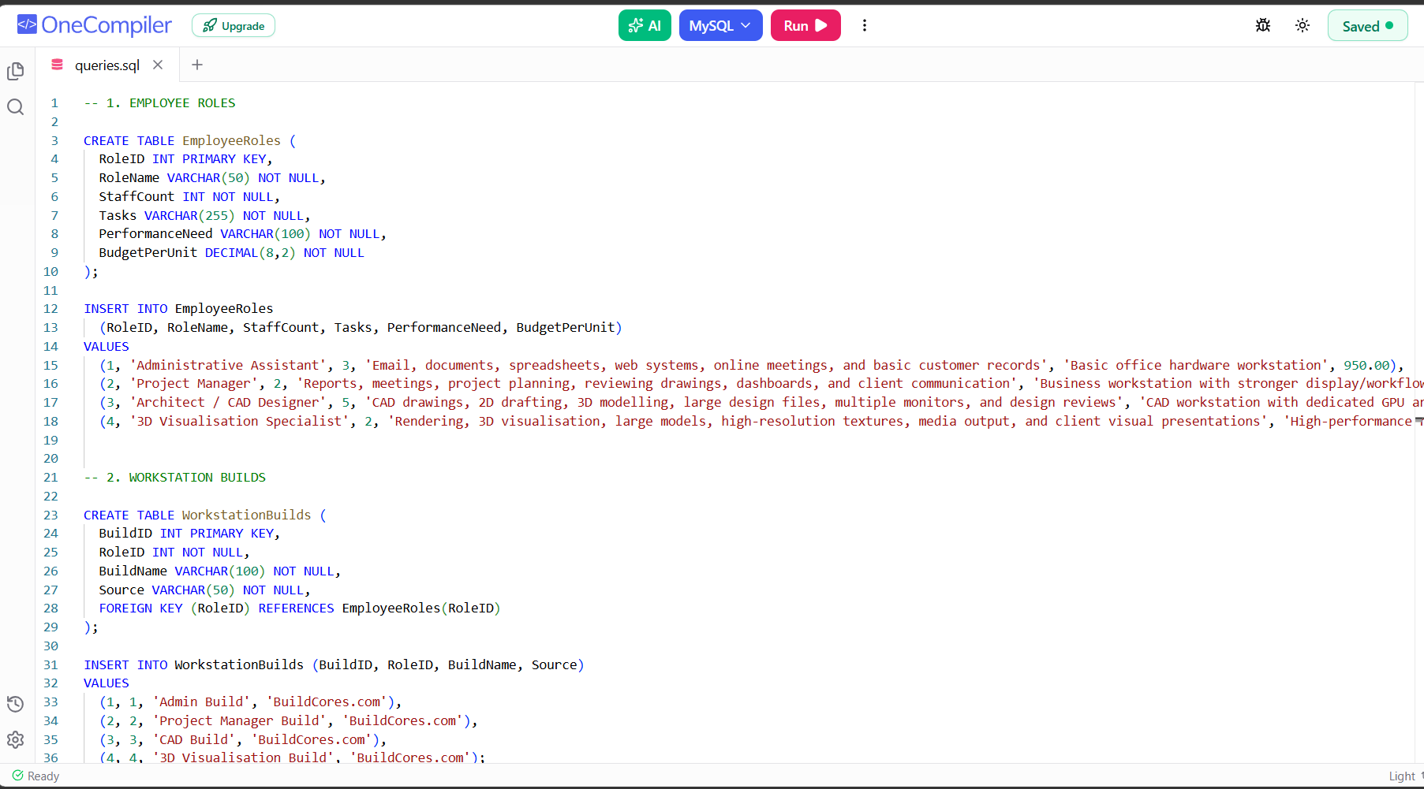

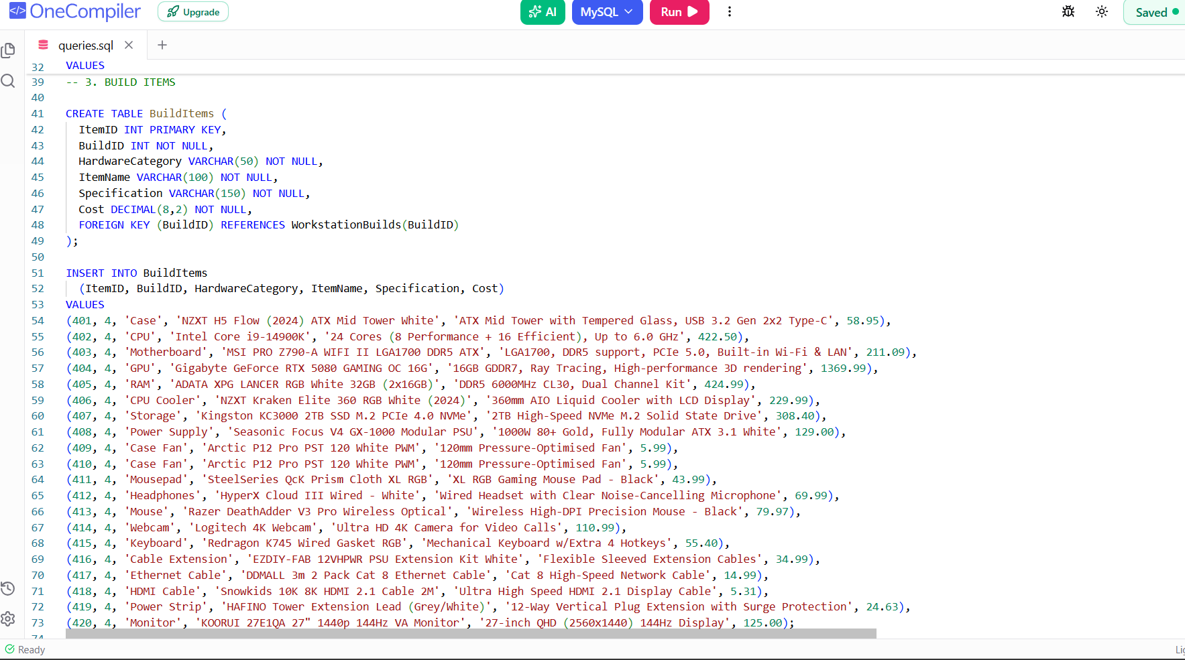

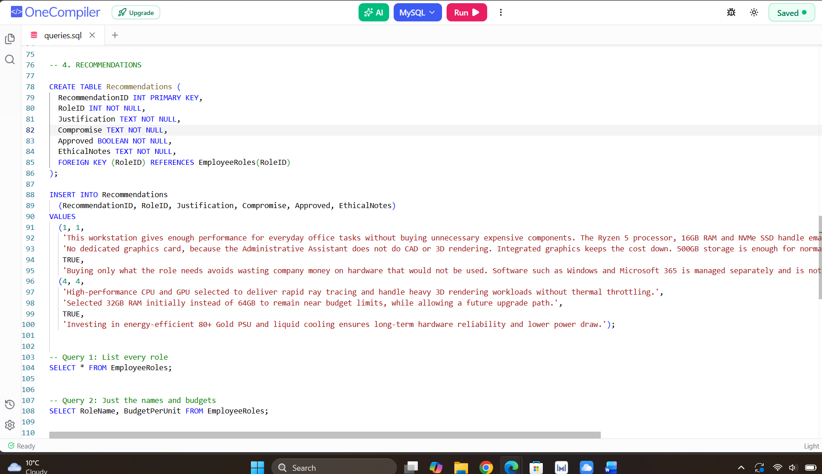

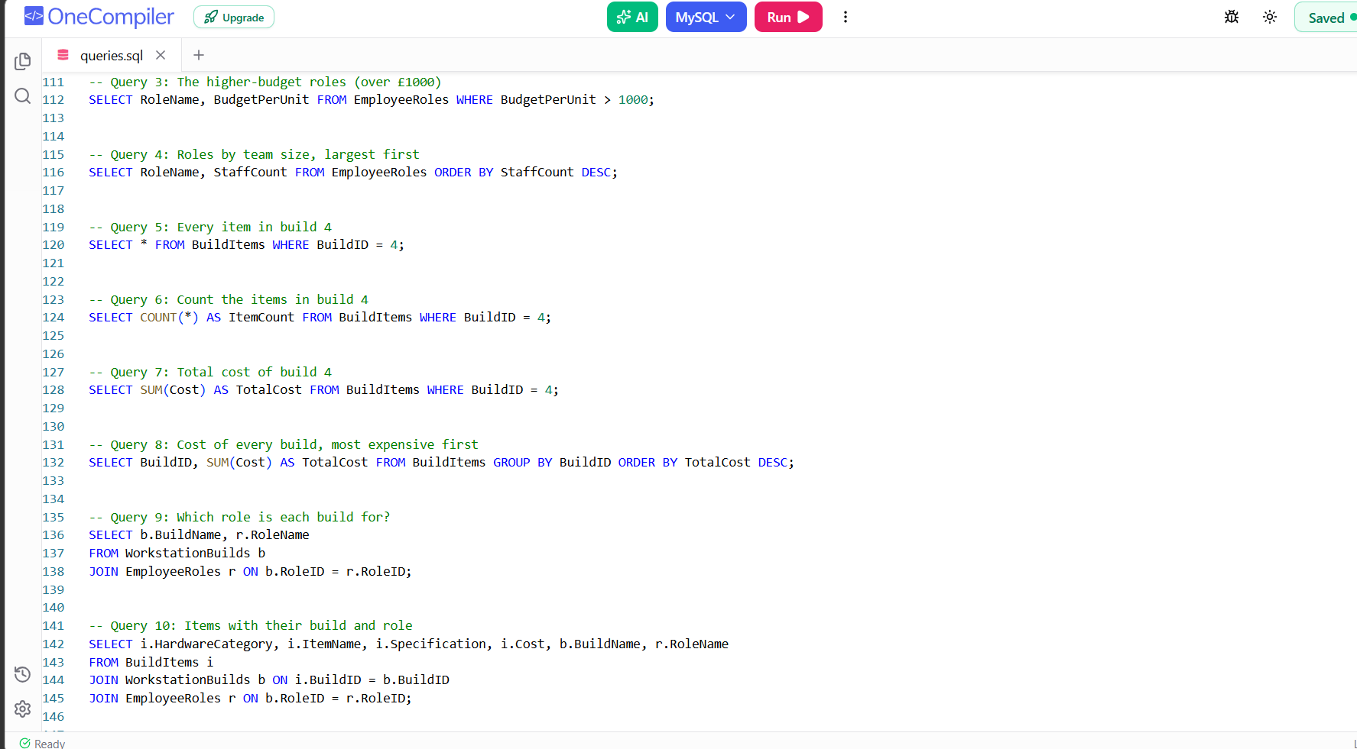

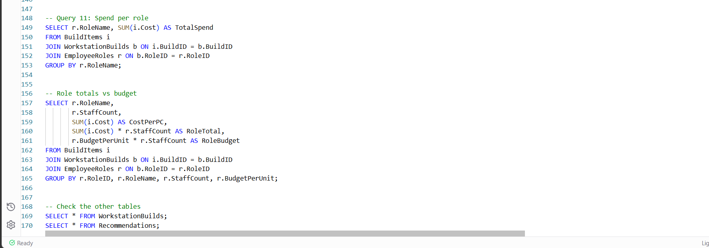

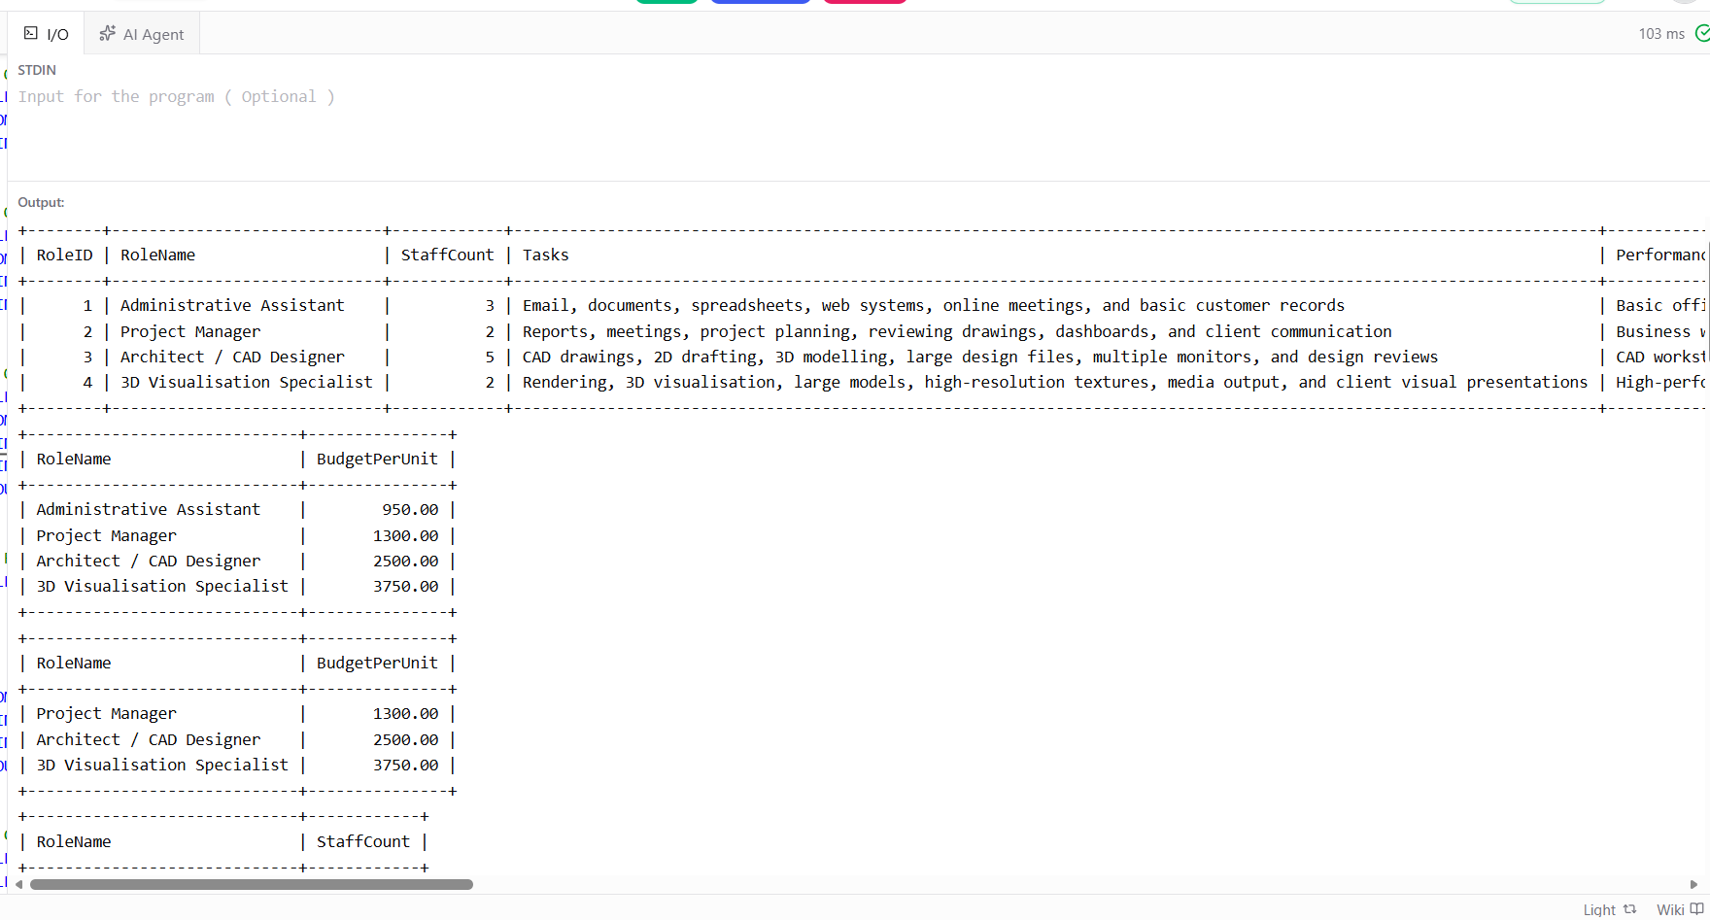

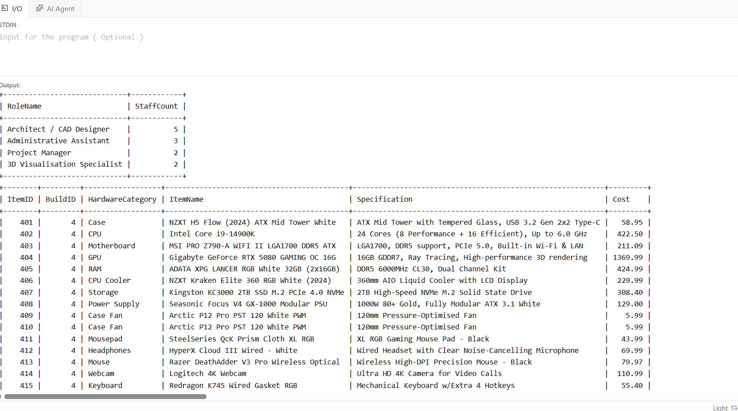

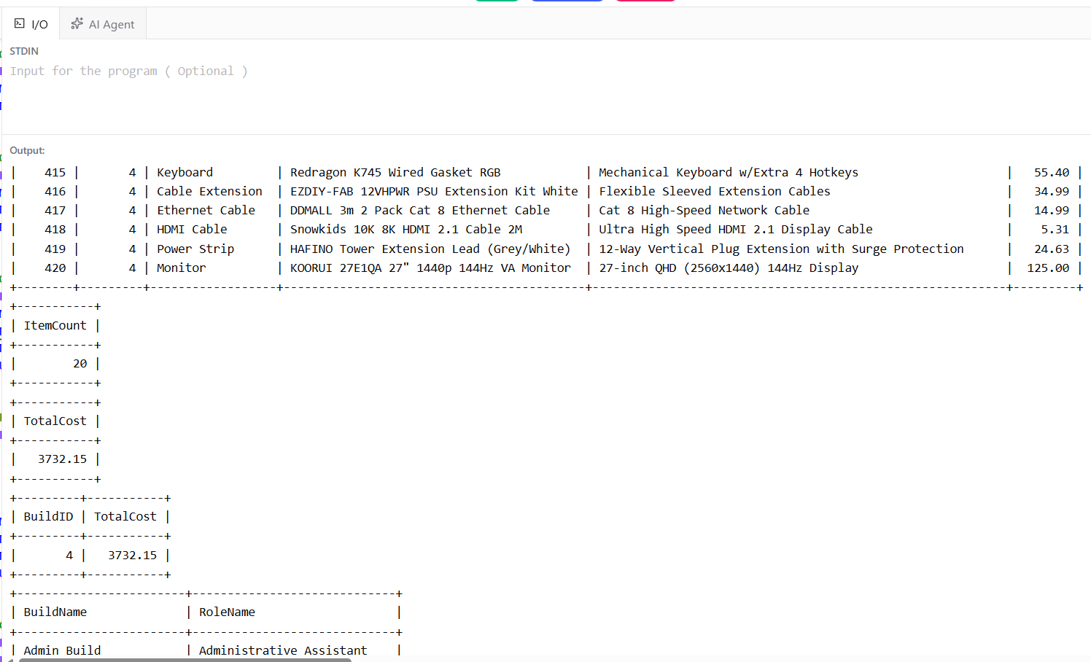

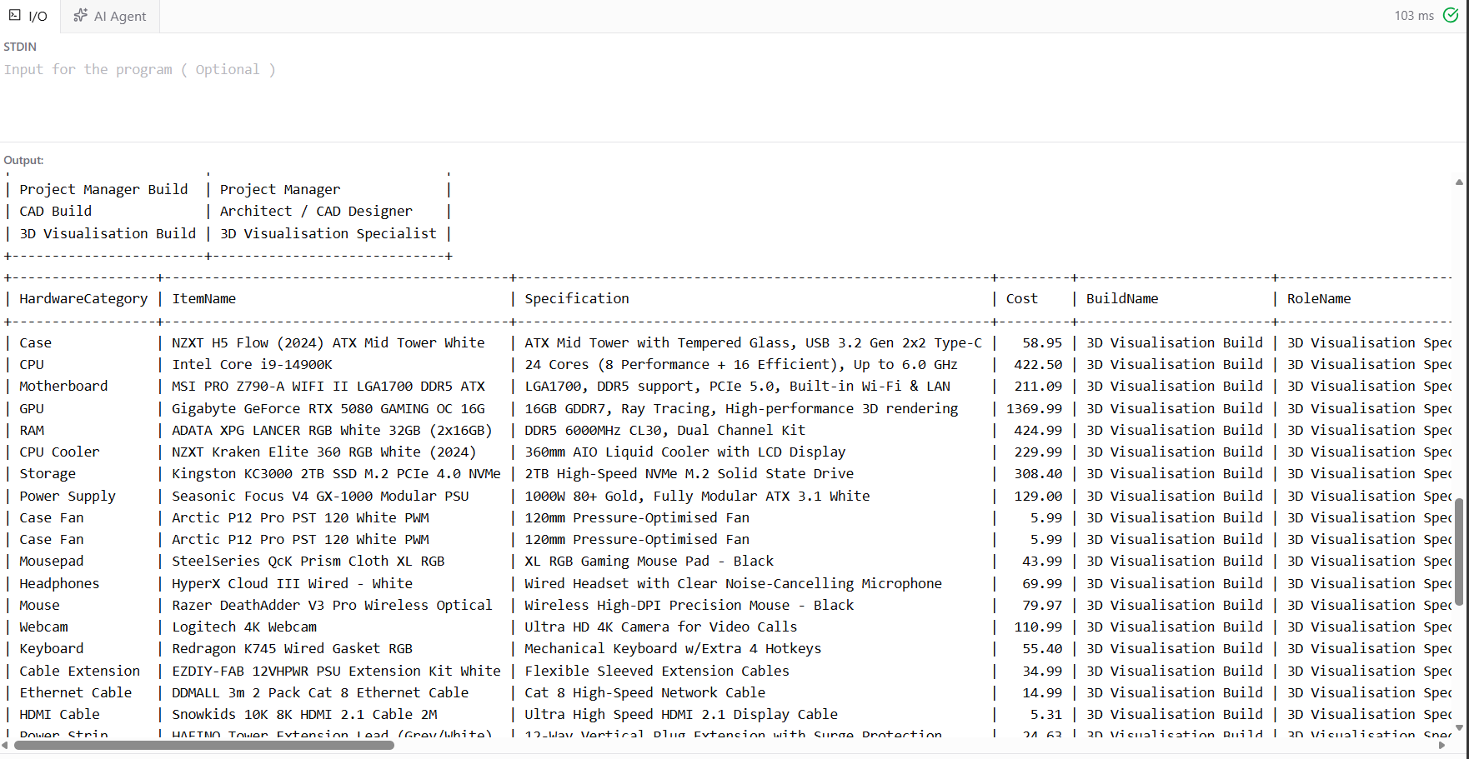

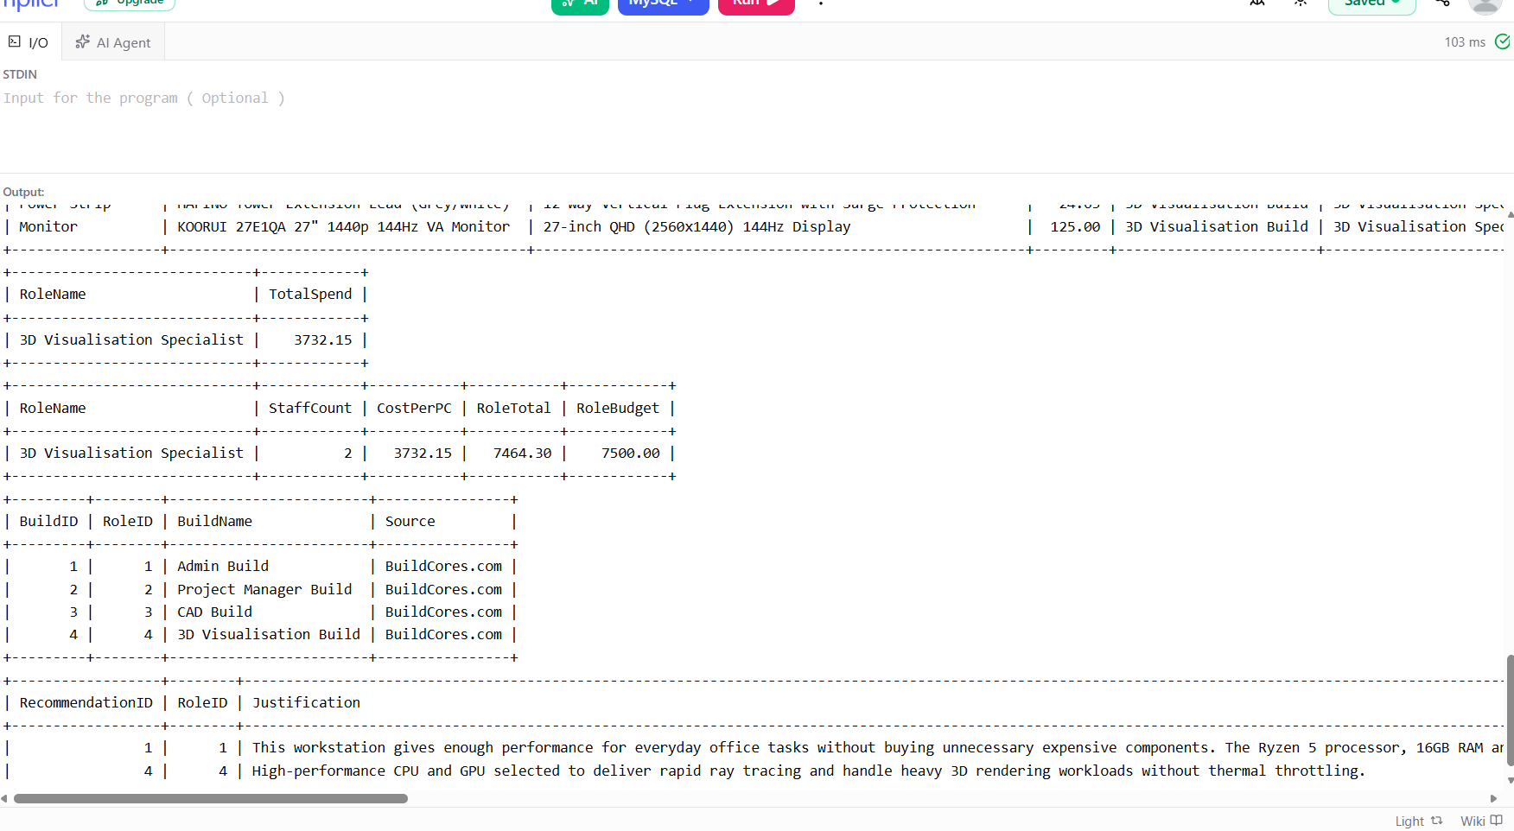

- Data Integrity:
While making the database, the data must be correct, organized, error-free, and should not contain duplicate information; that is actually called data integrity. We can maintain our databases by applying three main database controls, and these are:
- Primary Keys:
In a table, every entry must have a unique identifier. It means every row, like an employee job role, a workstation build, or an individual hardware part, contains its own new ID number, and this number is called a primary key. Two or more rows cannot have the same ID number. Every row should contain its own primary key, which helps to stop making duplicate rows in the database.

- Foreign Keys:
Any table connects with other tables through a foreign key. It means foreign keys help to create links between tables. For example: linking a specific graphics card or monitor in build items to a workstation build. So, it proves that the hardware items belong to the correct build.

- Data Types:
Every column strictly follows the data type rules for giving accurate output. There are multiple types of data types that apply according to the form of data. For example: decimal data type is used for numbers, and VARCHAR is used for saving letters and symbols. As we can see here in the table, decimal is used for costs and prices that will give correct budget output, and nobody can enter letters in it. So, data types play an important role in saving various information.

- Data Security:
Data security is one of the most important steps for companies, in which the databases should be secured properly from hackers and unauthorized people. When hackers get access to those databases, they can delete, change, or leak the clients’ confidential details and architectural designs. So, there are two main ways of protecting the information. One is saving the whole database record in a local SSD. And second, applying the rule of not giving permission to everybody to access this data. Make a clear rule that only an important group of people is allowed to open this database and able to make changes.

- Budget & Compromise Analysis:
Overall, the workstation that I proposed is perfectly suitable and a very decent choice for 3D Visualisation rendering work, but a few things could be better if the budget was higher. According to the company’s given budget, I compromised on a few things, but it still works well for the role, and the items are:
- 32GB RAM Choice:
The selected RAM is 32GB instead of 64GB just to manage the budget. It doesn’t mean it does not work well. This RAM is more than enough and works really well and smoothly for 3D rendering tasks. Choosing 32GB RAM saves money that was used to select other main parts that are more important for managing 3D tasks and performance. The important thing is I selected a motherboard that provides extra empty memory slots. The good thing is the company can add more RAM to it in the future and upgrade it as their big project needs desire.

- Storage (2TB NVMe SSD):
A 4TB SSD could have been selected instead of a 2TB NVMe SSD, but keeping our company’s overall budget in mind, we ended up choosing a 2TB SSD. It is not a bad choice at all, as it is capable of providing more than enough space for storing huge 3D projects, and the company can simply save their older tasks to cloud storage or external drives.

- GPU Choice (RTX 5080 vs RTX 5090):
The proposed GPU is the RTX 5080 instead of the RTX 5090 because the RTX 5090 is very expensive and would waste a lot more money on just one item. Therefore, we selected the RTX 5080, which delivers a good amount of power for a rendering computer and is suitable for 3D visualisation, saving budget that was used for buying other hardware specs.

- Ethical & Environmental Considerations
The main motto of building a PC is not just providing high performance. Other important things to consider are how long the specs we choose for our PC will last, and how comfortable a person feels maintaining good health while using that particular PC on a daily basis.
- Energy Saving and Efficiency:
My chosen PC contains a 1000W power supply with an 80+ Gold efficiency rating that provides power efficiently and is able to convert wall electricity into computer power energy without wasting a lot of energy in the form of heat. Apart from this, it saves on electricity bills, which is useful for the company's overall billing and energy usage.

- Longer Hardware Life:
Usually, when a PC is used for 3D visualisation rendering based on powerful spec parts like an Intel Core i9 processor and an RTX graphics card, it consumes more energy to complete big tasks, which makes the PC hot. So, I added a 360mm liquid cooler and extra fans to keep the PC cool. These extra cooling items help the computer work more efficiently and last for longer years.

- User Health and Comfort:
3D rendering PC users use them for long hours every day, so it’s essential to build these PCs by thinking about their comfort and health. Therefore, we added a 144Hz screen that gives a smooth visual effect to help protect their eye health. Also, an ergonomic mouse and a noise-cancelling headset were added to this workstation to help users avoid wrist pain and noise distractions.

- SQL Code Link:
https://onecompiler.com/mysql/456bjvnru

